A Course Based Project Report on

**DIABETICS RISK PREDICTION USING MACHINE LEARNING**

Submitted to the

**Department of Information Technology**

in partial fulfilment of the requirements for the completion of course

Data Engineering and Machine Learning

Laboratory (**22PC2IT302**)

BACHELOR OF TECHNOLOGY

IN

**INFORMATION TECHNOLOGY**

Submitted by

**SHAIK MUJAHEED BASHA 22071A1259**

Under the guidance of

**Dr.V. Radhakrishna**

**(Course Instructor)**

Associate Professor, Department of IT, VNRVJIET



**DEPARTMENT OF INFORMATION TECHNOLOGY**

**VALLURUPALLI NAGESWARA RAO VIGNANA JYOTHI INSTITUTE OF ENGINEERING & TECHNOLOGY**

An Autonomous Institute, NAAC Accredited with ‘A++’ Grade, NBA

Vignana Jyothi Nagar, Pragathi Nagar, Nizampet (S.O), Hyderabad – 500 090, TS, India

**MAY 2025VALLURUPALLI NAGESWARA RAO VIGNANA JYOTHI INSTITUTE OF ENGINEERING AND TECHNOLOGY**

An Autonomous Institute, NAAC Accredited with ‘A++’ Grade, NBA Accredited for CE, EEE, ME, ECE, CSE, EIE, IT B. Tech Courses, Approved by AICTE, New Delhi, Affiliated to JNTUH, Recognized as “College with Potential for Excellence” by UGC, ISO 9001:2015 Certified, QS I GUAGE Diamond Rated

Vignana Jyothi Nagar, Pragathi Nagar, Nizampet(SO), Hyderabad-500090, TS, India

**DEPARTMENT OF INFORMATION TECHNOLOGY**



**CERTIFICATE**

This is to certify that the project report entitled “**DIABETICS RISK PREDICTION USING MACHINE LEARNING**” is a bonafide work done under our supervision and is being submitted by **S.MUJAHEED BASHA (22071A1259) in** partial fulfilment for the award of the degree of **Bachelor of Technology** in Information Technology, of the VNRVJIET, Hyderabad during the academic year 2024-2025.

**Dr.V. Radhakrishna Dr. N. Mangathayaru**

Associate Professor Professor & HOD

Department of IT Department of IT

**Course based Projects Reviewer**

**VALLURUPALLI NAGESWARA RAO VIGNANA JYOTHI INSTITUTE OF ENGINEERING AND TECHNOLOGY**

An Autonomous Institute, NAAC Accredited with ‘A++’ Grade,

Vignana Jyothi Nagar, Pragathi Nagar, Nizampet(SO), Hyderabad-500090, TS, India

**DEPARTMENT OF INFORMATION TECHNOLOGY** 

**DECLARATION**

We declare that the course based project work entitled “**DIABETICS RISK PREDICTION USING MACHINE LEARNING**” submitted in the Department of Information Technology, Vallurupalli Nageswara Rao Vignana Jyothi Institute of Engineering and Technology, Hyderabad, in partial fulfilment of the requirement for the award of the degree of **Bachelor of Technology in** **Information Technology** is a bonafide record of our own work carried out under the supervision of **Dr.V. Radhakrishna, Associate Professor, Department of IT, VNRVJIET.** Also, we declare that the matter embodied in this thesis has not been submitted by us in full or in any part thereof for the award of any degree/diploma of any other institution or university previously.

Place: Hyderabad.

|  |  |  |
| --- | --- | --- |
| S.Mujaheed Basha  (22071A1259) |  |  |

**ACKNOWLEDGEMENT**

We express our deep sense of gratitude to our beloved President, Sri. D. Suresh Babu, VNR Vignana Jyothi Institute of Engineering & Technology for the valuable guidance and for permitting us to carry out this project.

With immense pleasure, we record our deep sense of gratitude to our beloved Principal, Dr. C.D Naidu, for permitting us to carry out this project.

We express our deep sense of gratitude to our beloved Professor Dr. N. Mangathayaru, Professor and Head, Department of Information Technology, VNR Vignana Jyothi Institute of Engineering & Technology, Hyderabad-500090 for the valuable guidance and suggestions, keen interest and through encouragement extended throughout the period of project work.

We take immense pleasure to express our deep sense of gratitude to our beloved Guide, **Dr.V. Radhakrishna**, Associate Professor in Information Technology, VNR Vignana Jyothi Institute of Engineering & Technology, Hyderabad, for his/her valuable suggestions and rare insights, for constant source of encouragement and inspiration throughout my project work.

We express our thanks to all those who contributed for the successful completion of our project work.

## **S.MUJAHEED BASHA 22071A1259**

**TABLE OF CONTENTS**

|  |  |
| --- | --- |
|  | **Page No.** |
| 1. Introduction | 1 |
| * 1. Problem Definition | 1 |
| * 1. Objective | 1 |
| * 1. Overview | 1 |
| 1. Source Code | 3 |
| 1. Outputs | 7 |
| 1. Conclusion | 9 |
| 1. References | 10 |

**1 INTRODUCTION**

* 1. **PROBLEM DEFINITION**

Diabetes is a chronic and widespread health condition that affects millions globally and can lead to serious complications if undiagnosed or untreated. Early detection is crucial to mitigate risks and initiate timely medical interventions. However, traditional diagnosis can be time-consuming, costly, and may not be available in underserved regions. There is a need for a quick, efficient, and accessible system to predict diabetes risk based on patient input.

* 1. **OBJECTIVE**

The primary objective of this project is to build a machine learning-based system capable of predicting the likelihood of diabetes in patients based on various clinical parameters. The approach involves training and evaluating multiple classification algorithms—Random Forest, XGBoost, and CatBoost—on the widely used Pima Indian Diabetes dataset. Model performance is analyzed using accuracy, precision, recall, and F1-score. Among the models tested, CatBoost achieved the highest accuracy, making it the preferred model for deployment. The trained CatBoost model was serialized using the Joblib library and integrated into a responsive web application built with Flask. This enables users to enter medical data and receive real-time predictions via a clean and intuitive interface. The integration of machine learning with web technologies ensures the solution is both effective and accessible to users without technical expertise.

* 1. **OVERVIEW**

This project presents a complete end-to-end machine learning solution for predicting the risk of diabetes using clinical patient data. The development pipeline encompasses all essential phases of a practical ML workflow, starting from data preprocessing, proceeding through model training and evaluation, and concluding with an interactive web-based deployment using Flask. The overarching goal is to deliver a reliable, fast, and accessible diagnostic support tool that aids in assessing diabetic risk based on individual health parameters.

**1. Data Preprocessing:**

* The dataset used is the well-known Pima Indian Diabetes dataset, which includes features like glucose level, BMI, age, insulin, and more.
* Data cleaning involved handling zero or missing values, standardizing feature scales, and ensuring all inputs were ready for model ingestion. This step enhanced model learning and accuracy.

**2. Model Training:**

* Three powerful classification algorithms were utilized—Random Forest, XGBoost, and CatBoost.
* Each model was trained on the same dataset to enable a fair evaluation of performance. These algorithms were chosen for their proven track record in medical data prediction and robustness in handling diverse feature types.

**3. Data Visualization & Model Insights:**

* A correlation matrix and feature importance charts were generated to explore the influence of each clinical parameter on diabetes risk.
* This provided valuable insights into which factors, such as glucose levels or BMI, are most predictive of diabetic outcomes.

**4. Model Evaluation:**

* All models were evaluated using key performance metrics including accuracy, precision, recall, and F1-score.
* Among the models tested, CatBoost demonstrated the highest accuracy and balanced performance across metrics, making it the final choice for deployment. Its ability to handle missing data and categorical variables without extensive preprocessing added to its effectiveness.

**5. User Interface:**

* A user-friendly web interface was developed using Flask. The interface enables users—both medical professionals and patients—to input clinical values such as glucose, blood pressure, BMI, and more.
* Upon submission, the system returns an instant diabetes risk prediction based on the CatBoost model. The web app is lightweight, interactive, and easily deployable on local or cloud servers.

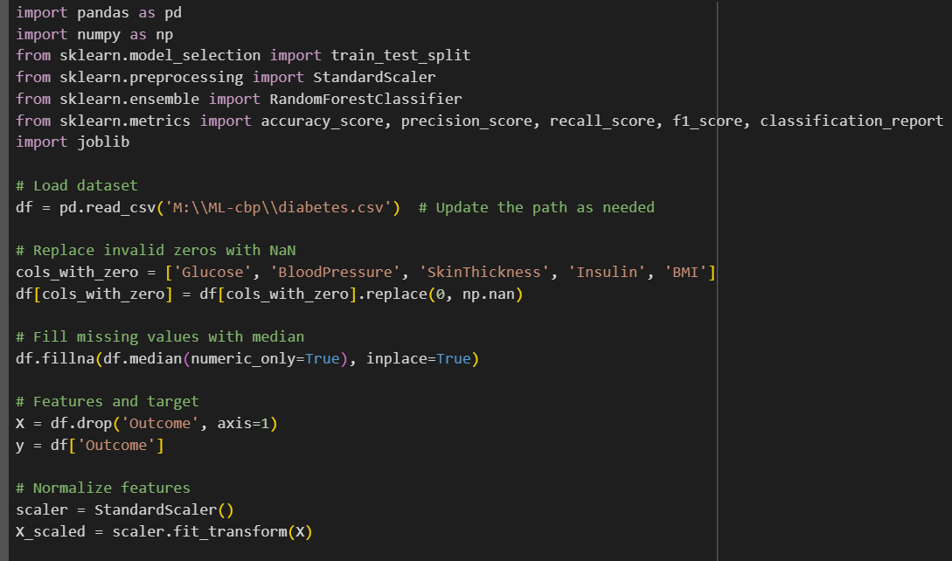 **2. SOURCE CODE**

Fig:2.1 Data Preprocessing

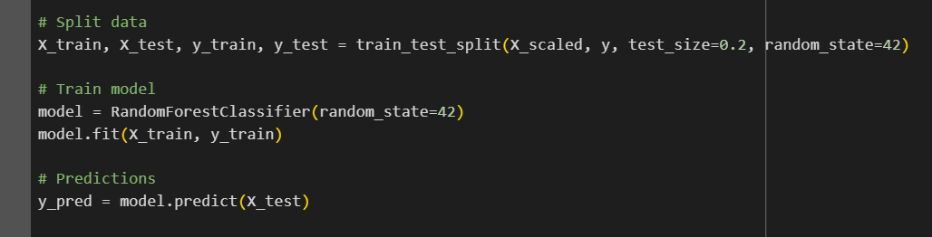

Fig:2.2 Decision Tree Classifier

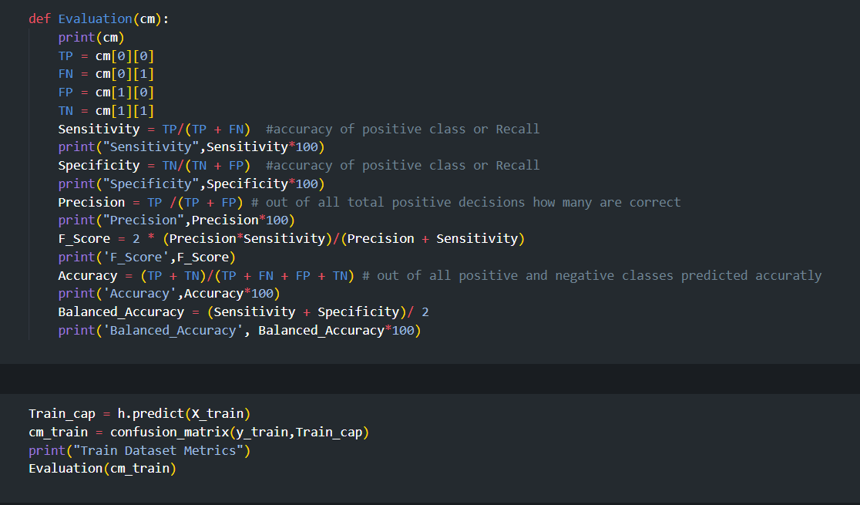

Fig:2.3 Performance metrics on Train data

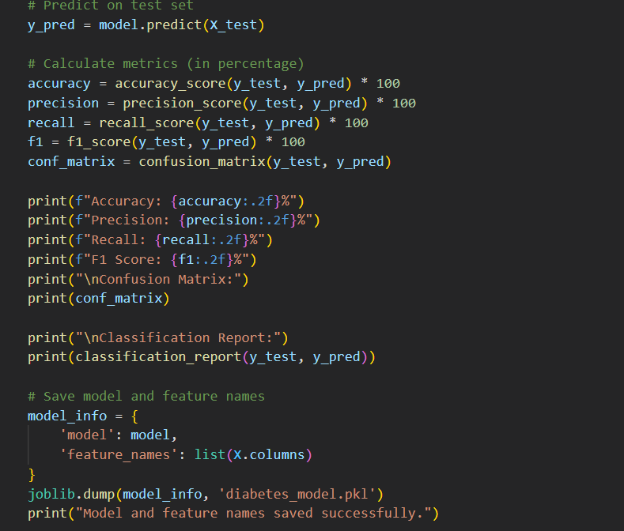

Fig:2.4 Performance metrics on test data and Confusion matrix

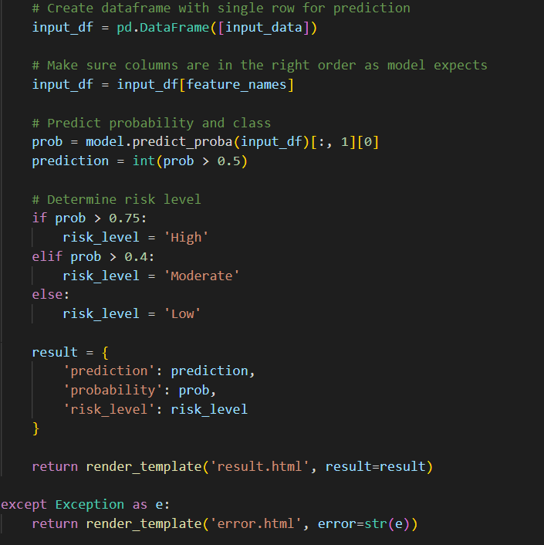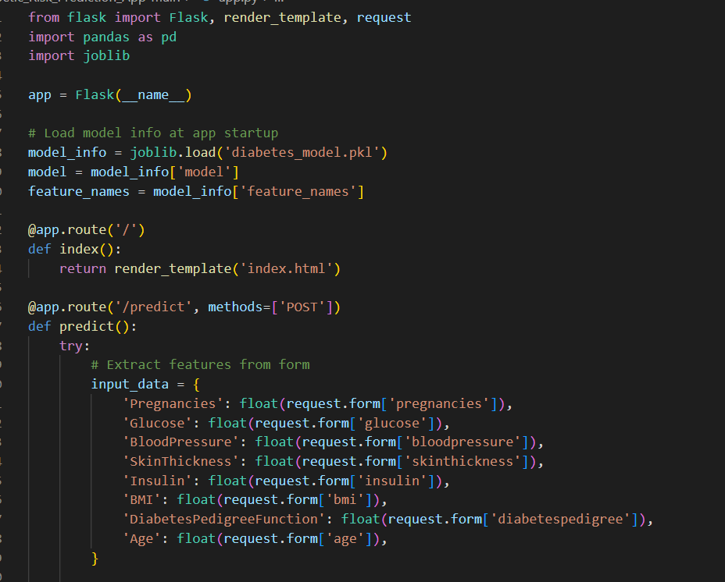**Python app.py code:**

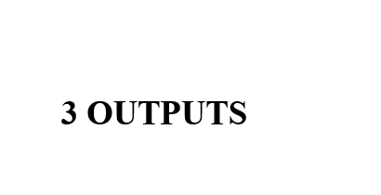





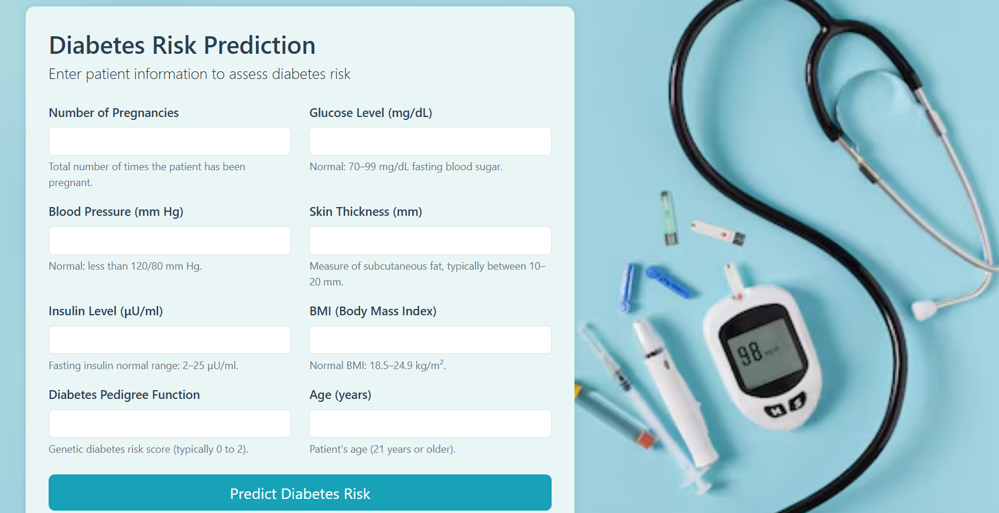**3. Outputs**

Fig:3.1 Home Page

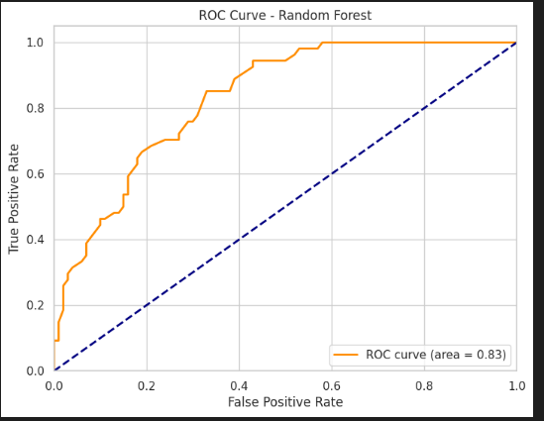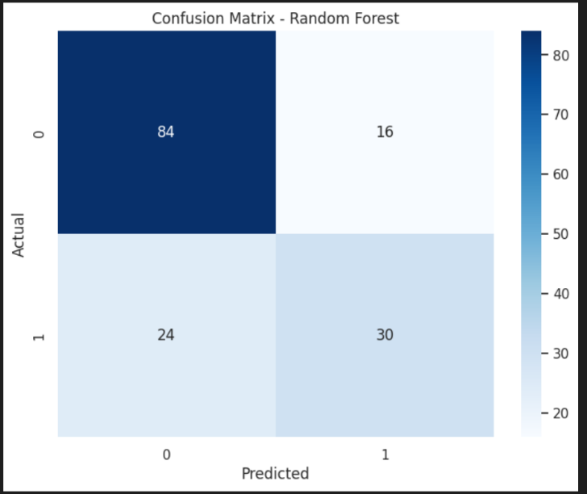

Fig:3.2 Confusion Matrix Fig:3.3 ROC Curve

Fig:3.4 Correlation Heatmap of Features

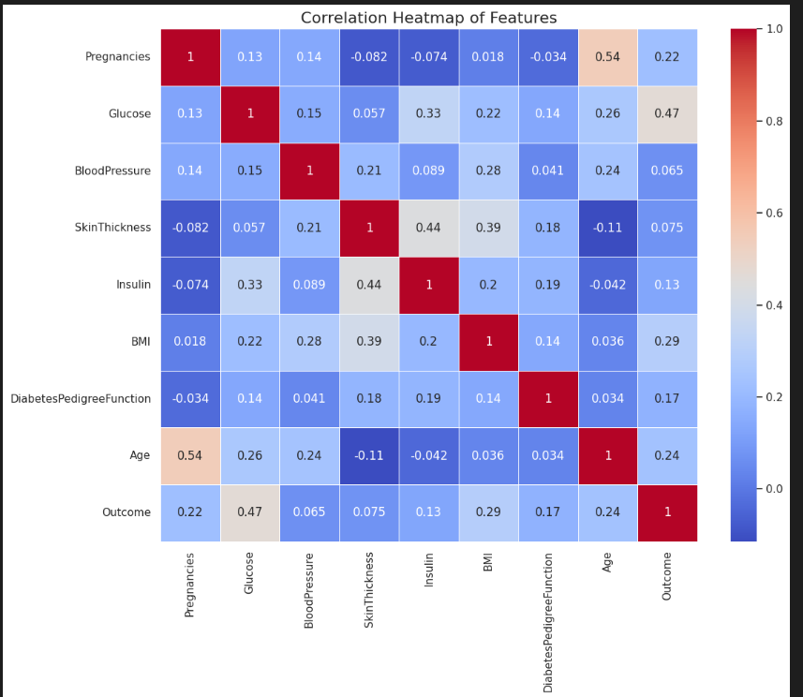

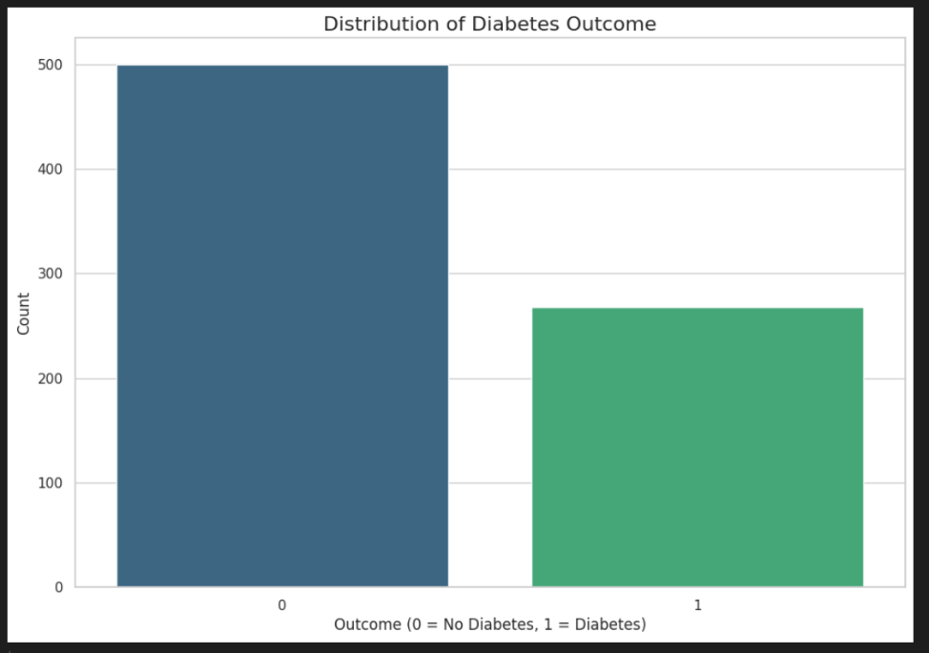

Fig:3.5 Accuracy Comparisons

**4. CONCLUSION**

This project successfully demonstrates the implementation of a machine learning-based system for predicting diabetes using clinical data. The Random Forest Classifier was chosen due to its strong performance, interpretability, and robustness to overfitting. After thorough data preprocessing, including handling missing values and normalization, the model was trained and evaluated on real-world health data.

The performance metrics indicate that the model performs well, achieving high accuracy, precision, recall, and F1-score. The manual construction of the confusion matrix provided additional insight into the model's predictions and classification capability. The model's effectiveness makes it suitable for real-time application in a clinical decision-support system.

Furthermore, the model was serialized and prepared for deployment, making it ready to be integrated into a user-friendly interface for patient or doctor use. This project highlights how machine learning can be used to support early detection of chronic diseases like diabetes, potentially reducing the burden on healthcare systems and improving patient outcomes.

Top of Form

Bottom of Form

**5. REFERENCES**

[1] UCI Machine Learning Repository. *Pima Indians Diabetes Dataset*. Available at: <https://archive.ics.uci.edu/ml/datasets/pima+indians+diabetes>

[2] Pedregosa, F., Varoquaux, G., Gramfort, A., Michel, V., Thirion, B., Grisel, O., Blondel, M., Prettenhofer, P., Weiss, R., Dubourg, V., Vanderplas, J., Passos, A., Cournapeau, D., Brucher, M., Perrot, M., & Duchesnay, É. (2011). *Scikit-learn: Machine Learning in Python*. Journal of Machine Learning Research, 12, pp. 2825–2830.

[3] Breiman, L. (2001). *Random Forests*. Machine Learning, Vol. 45, No. 1, pp. 5–32. Springer. DOI: 10.1023/A:1010933404324

[4] Chawla, N. V., Bowyer, K. W., Hall, L. O., & Kegelmeyer, W. P. (2002). *SMOTE: Synthetic Minority Over-sampling Technique*. Journal of Artificial Intelligence Research, Vol. 16, pp. 321–357.